index.html:
<!DOCTYPE html>
<html lang="en">
<head>
<meta charset="UTF-8" />
<meta name="viewport" content="width=device-width, initial-scale=1.0" />
<title>Experiment 1 - Matomo Analytics</title>
<link rel="stylesheet" href="style.css" />

<!-- Matomo -->
<script>
var _paq = (window._paq = window._paq || []);
/* tracker methods like "setCustomDimension" should be called before "trackPageView" */
_paq.push(["trackPageView"]);
_paq.push(["enableLinkTracking"]);
(function () {
var u = "//localhost/matomo/";
_paq.push(["setTrackerUrl", u + "matomo.php"]);
_paq.push(["setSiteId", "1"]);
var d = document,
g = d.createElement("script"),
s = d.getElementsByTagName("script")[0];
g.async = true;
g.src = u + "matomo.js";
s.parentNode.insertBefore(g, s);
})();
</script>
<!-- End Matomo Code -->
</head>
<body>
<main class="container">
<h1>Experiment 1: Web Analytics Using Matomo</h1>
<p>
This page demonstrates how to integrate Matomo, an open-source analytics tool.
Matomo tracking is configured for <strong>localhost/matomo</strong> with Site ID <strong>1</strong>.
Update these values in the tracking snippet if your Matomo setup is different.
</p>

<section>
<h2>What This Tracks</h2>
<ul>
<li>Page views</li>
<li>Visit duration</li>
<li>Custom button click event below</li>
</ul>
</section>

<button id="trackButton" type="button">Track Sample Event</button>
<p id="status" aria-live="polite"></p>

<p>Devang Deokule - A58</p>
</main>

<script src="script.js"></script>
</body>
</html>

script.js:
var trackButton = document.getElementById("trackButton");

if (trackButton) {
trackButton.addEventListener("click", function () {
var paq = (window._paq = window._paq || []);
paq.push(["trackEvent", "Experiment", "ButtonClick", "Sample Event"]);

var status = document.getElementById("status");
if (status) {
status.textContent = "Sample Matomo event queued.";
}
});
}

style.css:
body {
margin: 0;
font-family: Georgia, "Times New Roman", serif;
line-height: 1.5;
min-height: 100vh;
display: flex;
justify-content: center;
padding: 1.5rem 1rem;
background: #f8f8f8;
}
.container {
width: min(100%, 760px);
padding: 1.5rem;
border: 1px solid #d8d8d8;
background: #fff;
}
h1,
h2 {
margin: 0 0 0.65rem;
}
h1 {
max-width: 28ch;
margin-left: auto;
margin-right: auto;
text-align: center;
font-weight: 700;
line-height: 1.25;
display: -webkit-box;
-webkit-line-clamp: 2;
-webkit-box-orient: vertical;
overflow: hidden;
}
button {
border: 1px solid #444;
background: #f5f5f5;
padding: 0.5rem 0.9rem;
cursor: pointer;
}
#status {
margin-top: 0.9rem;
min-height: 1.5rem;
}
section,
ul,
p,
button {
margin-top: 0.8rem;

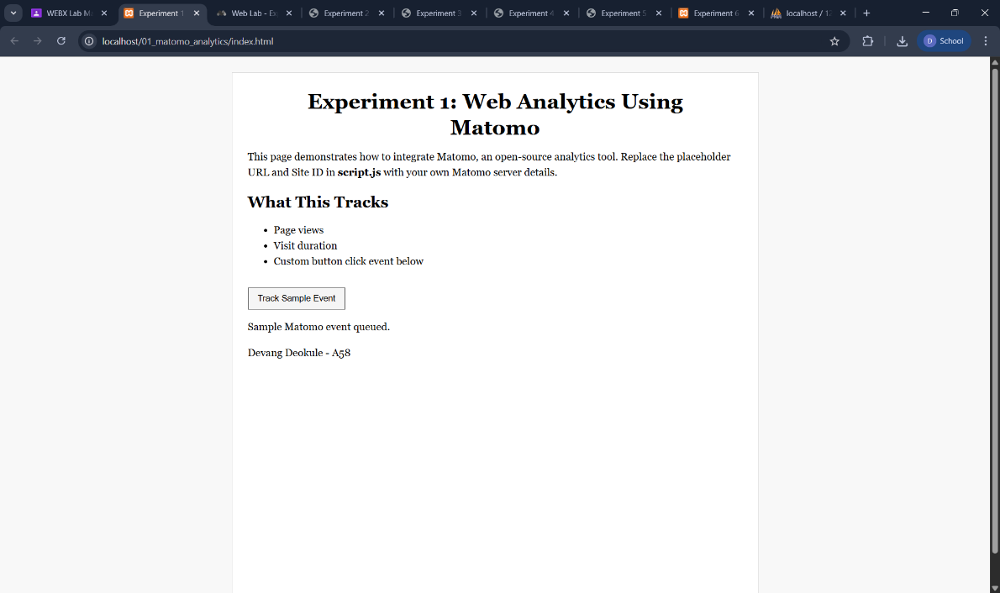
Output:

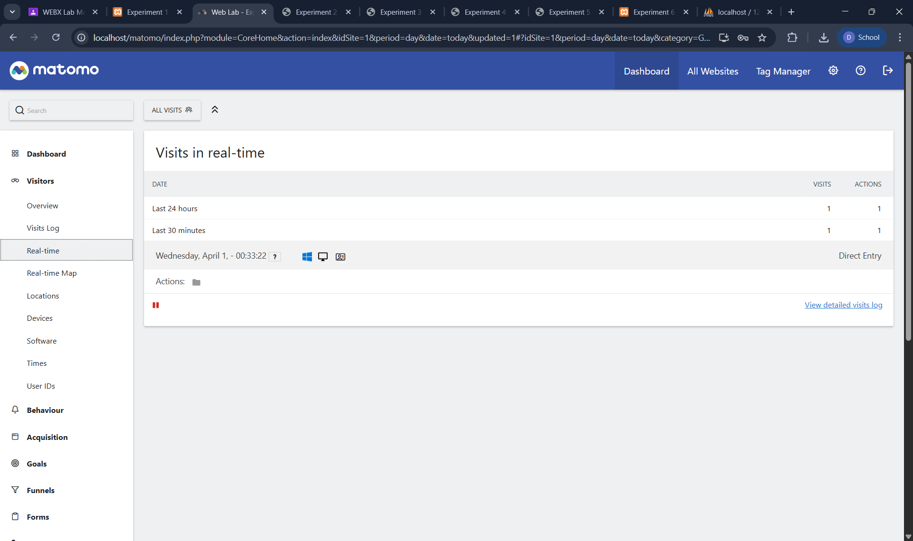

index.html:
<!DOCTYPE html>
<html lang="en">
<head>
<meta charset="UTF-8" />
<meta name="viewport" content="width=device-width, initial-scale=1.0" />
<title>Experiment 2 - TypeScript Calculator</title>
<link rel="stylesheet" href="styles.css" />
</head>
<body>
<main class="container">
<h1>Experiment 2: Calculator in TypeScript</h1>

<div class="row">
<label for="num1">First Number</label>
<input id="num1" type="number" value="10" />
</div>

<div class="row">
<label for="num2">Second Number</label>
<input id="num2" type="number" value="5" />
</div>

<div class="row">
<label for="operator">Operator</label>
<select id="operator">
<option value="+">+</option>
<option value="-">-</option>
<option value="*">*</option>
<option value="/">/</option>
</select>
</div>

<button id="calculateBtn" type="button">Calculate</button>
<p id="result"></p>

<p>Devang Deokule - A58</p>
</main>

<script src="calculator.js"></script>
</body>
</html>

calculator.js:
var Calculator = /** @class */ (function () {
function Calculator() {}
Calculator.prototype.compute = function (a, b, op) {
switch (op) {
case "+":
return a + b;
case "-":
return a - b;
case "*":
return a * b;
case "/":
if (b === 0) {
throw new Error("Division by zero is not allowed.");
}
return a / b;
}
};
return Calculator;
})();

var calculator = new Calculator();
var calculateBtn = document.getElementById("calculateBtn");
var resultNode = document.getElementById("result");

calculateBtn.addEventListener("click", function () {
var num1 = Number(document.getElementById("num1").value);
var num2 = Number(document.getElementById("num2").value);
var operator = document.getElementById("operator").value;

try {
var result = calculator.compute(num1, num2, operator);
resultNode.textContent = "Result: " + result;
} catch (error) {
resultNode.textContent = error && error.message ? error.message : "Unexpected error.";
}
});

styles.css:
body {
margin: 0;
font-family: Cambria, Cochin, Georgia, serif;
min-height: 100vh;
display: flex;
justify-content: center;
padding: 1.5rem 1rem;
background: #f8f8f8;
}

.container {
width: min(100%, 520px);
padding: 1.5rem;
border: 1px solid #d8d8d8;
background: #fff;
}

.row {
margin: 0.9rem 0;
}

h1 {
max-width: 26ch;
margin: 0 auto 1rem;
text-align: center;
font-weight: 700;
line-height: 1.25;
display: -webkit-box;
-webkit-line-clamp: 2;
-webkit-box-orient: vertical;
overflow: hidden;
}

label {
display: block;
margin-bottom: 0.35rem;
}

input,
select,
button {
font: inherit;
width: 100%;
padding: 0.45rem 0.55rem;
border: 1px solid #555;
box-sizing: border-box;
}

button {
background: #efefef;
cursor: pointer;
}

#result {
margin-top: 0.95rem;
font-weight: 600;
min-height: 1.3rem;
}

Output:
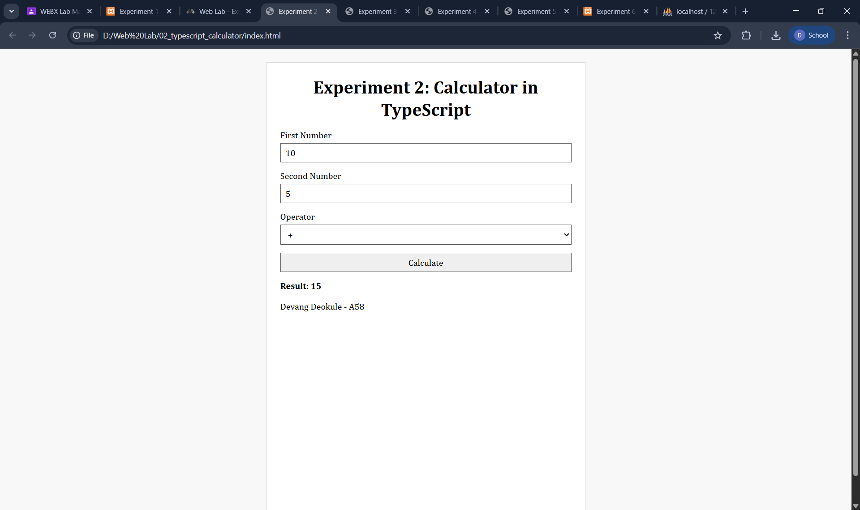

index.html:
<!DOCTYPE html>
<html lang="en">
<head>
<meta charset="UTF-8" />
<meta name="viewport" content="width=device-width, initial-scale=1.0" />
<title>Experiment 3 - TypeScript Multilevel Inheritance</title>
<link rel="stylesheet" href="styles.css" />
</head>
<body>
<main class="container">
<h1>Experiment 3: Multilevel Inheritance in TypeScript</h1>
<p>This example shows inheritance chain: Person - Student - GraduateStudent.</p>
<button id="showBtn" type="button">Show Output</button>
<pre id="output"></pre>
<p>Devang Deokule - A58</p>
</main>

<script src="inheritance.js"></script>
</body>
</html>

inheritance.ts:
export {};

class Person {
constructor(protected name: string) {}

public describe(): string {
return `Name: ${this.name}`;
}
}

class Student extends Person {
constructor(name: string, protected rollNo: number) {
super(name);
}

public describe(): string {
return `${super.describe()}\nRoll No: ${this.rollNo}`;
}
}

class GraduateStudent extends Student {
constructor(name: string, rollNo: number, private specialization: string) {
super(name, rollNo);
}

public describe(): string {
return `${super.describe()}\nSpecialization: ${this.specialization}`;
}
}

document.getElementById("showBtn")?.addEventListener("click", () => {
const graduate = new GraduateStudent("Devang Deokule", 58, "Information Technology");
const output = document.getElementById("output") as HTMLPreElement;
output.textContent = graduate.describe();
});

styles.css:

body {
margin: 0;
font-family: "Segoe UI", Tahoma, Geneva, Verdana, sans-serif;
min-height: 100vh;
display: flex;
justify-content: center;
padding: 1.5rem 1rem;
background: #f8f8f8;
}

.container {
width: min(100%, 720px);
padding: 1.5rem;
border: 1px solid #d8d8d8;
background: #fff;
}

h1 {
max-width: 28ch;
margin: 0 auto 1rem;
text-align: center;
font-weight: 700;
line-height: 1.25;
display: -webkit-box;
-webkit-line-clamp: 2;
-webkit-box-orient: vertical;
overflow: hidden;
}

button {
border: 1px solid #444;
background: #f0f0f0;
padding: 0.45rem 0.85rem;
cursor: pointer;
}

pre {
margin-top: 1rem;
border: 1px solid #ddd;
padding: 0.8rem;
background: #fafafa;
white-space: pre-wrap;
}

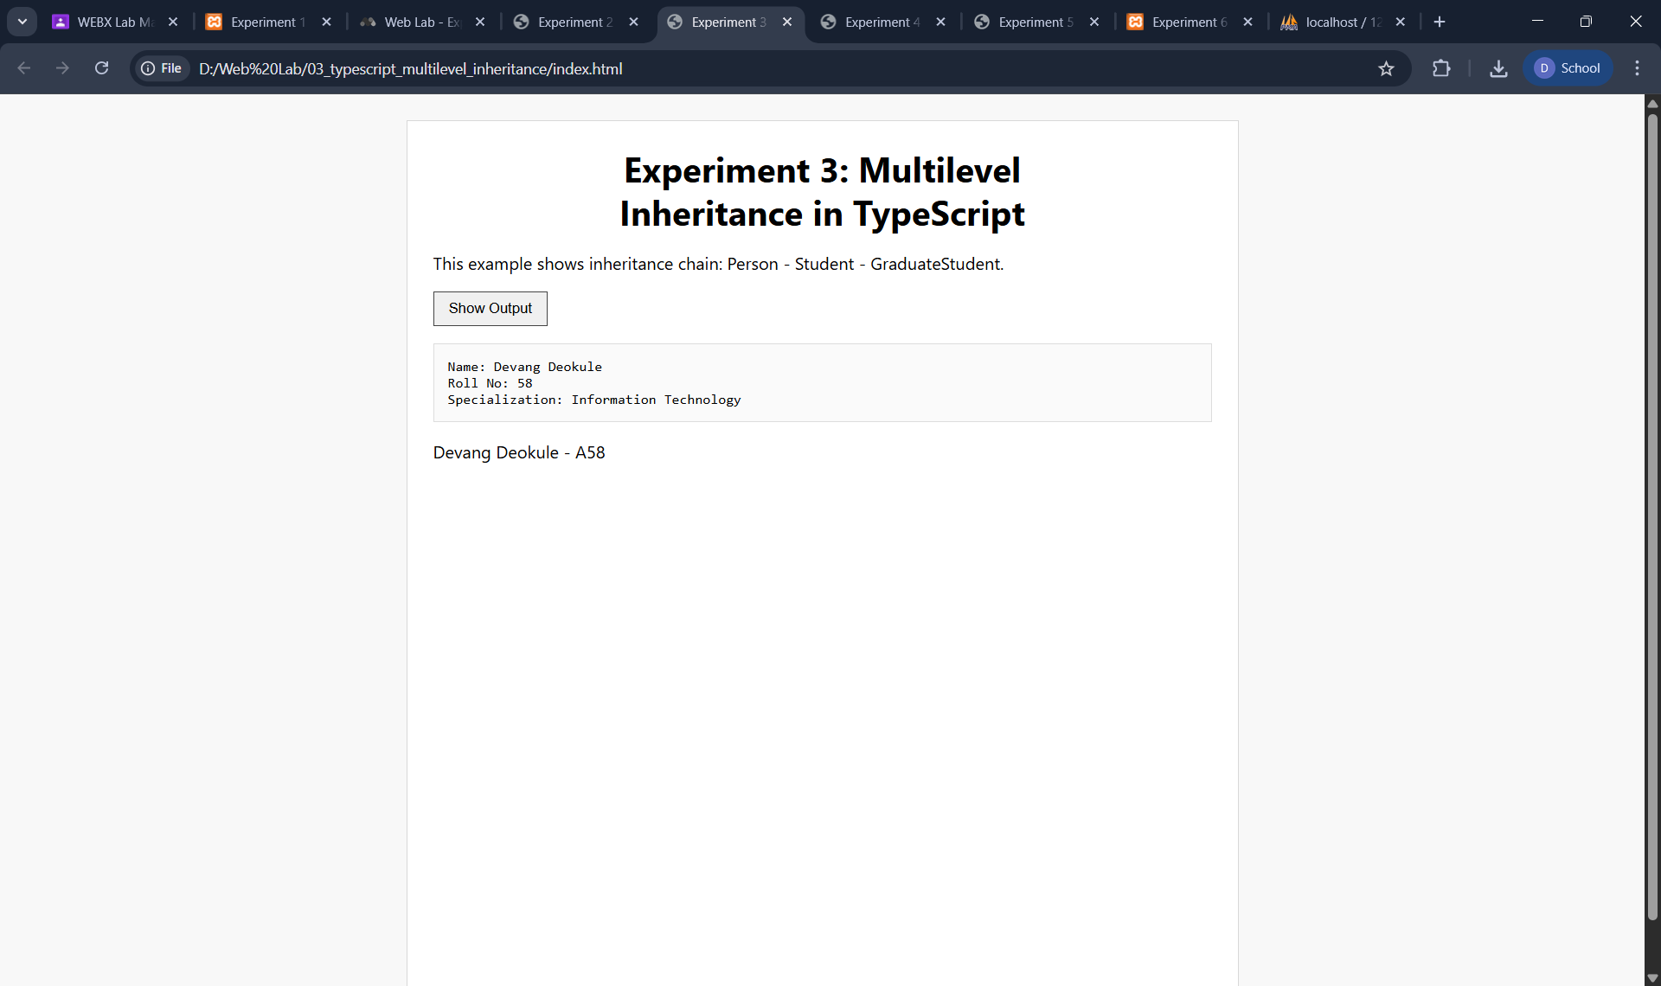
Output:

index.html:
<!DOCTYPE html>
<html lang="en" ng-app="basicSpaApp">
<head>
<meta charset="UTF-8" />
<meta name="viewport" content="width=device-width, initial-scale=1.0" />
<title>Experiment 4 - AngularJS SPA Basic</title>
<link rel="stylesheet" href="styles.css" />
<script src="https://ajax.googleapis.com/ajax/libs/angularjs/1.8.3/angular.min.js"></script>
<script src="https://ajax.googleapis.com/ajax/libs/angularjs/1.8.3/angular-route.min.js"></script>
</head>
<body>
<main class="container">
<h1>Experiment 4: AngularJS Single Page Application</h1>
<nav>
<a href="#!/home">Home</a>
<a href="#!/about">About</a>
<a href="#!/contact">Contact</a>
</nav>
<section ng-view></section>
<p>Devang Deokule - A58</p>
</main>

<script src="app.js"></script>
</body>
</html>

app.js:
var app = angular.module("basicSpaApp", ["ngRoute"]);
app.config(function ($routeProvider) {
$routeProvider
.when("/home", {
template: "<h2>Home</h2><p>Welcome to the AngularJS SPA home page.</p>"
})
.when("/about", {
template: "<h2>About</h2><p>This page demonstrates routing using ngRoute.</p>"
})
.when("/contact", {
template: "<h2>Contact</h2><p>Email: deokuledevang@gmail.com</p>"
})
.otherwise({
redirectTo: "/home"
});
});

styles.css:
body {
margin: 0;
font-family: "Trebuchet MS", sans-serif;
min-height: 100vh;
display: flex;
justify-content: center;
padding: 1.5rem 1rem;
background: #f8f8f8;
}
.container {
width: min(100%, 760px);
padding: 1.5rem;
border: 1px solid #d8d8d8;
background: #fff;
}
h1 {
max-width: 30ch;
margin: 0 auto 1rem;
text-align: center;
font-weight: 700;
line-height: 1.25;
display: -webkit-box;
-webkit-line-clamp: 2;
-webkit-box-orient: vertical;
overflow: hidden;
}
nav {
margin: 1rem 0;
display: flex;
flex-wrap: wrap;
gap: 0.6rem;
}
nav a {
margin-right: 0;
padding: 0.25rem 0.4rem;
text-decoration: none;
color: inherit;
border-bottom: 1px solid #ccc;
}
[ng-view] {
padding-top: 0.7rem;
}

Output:
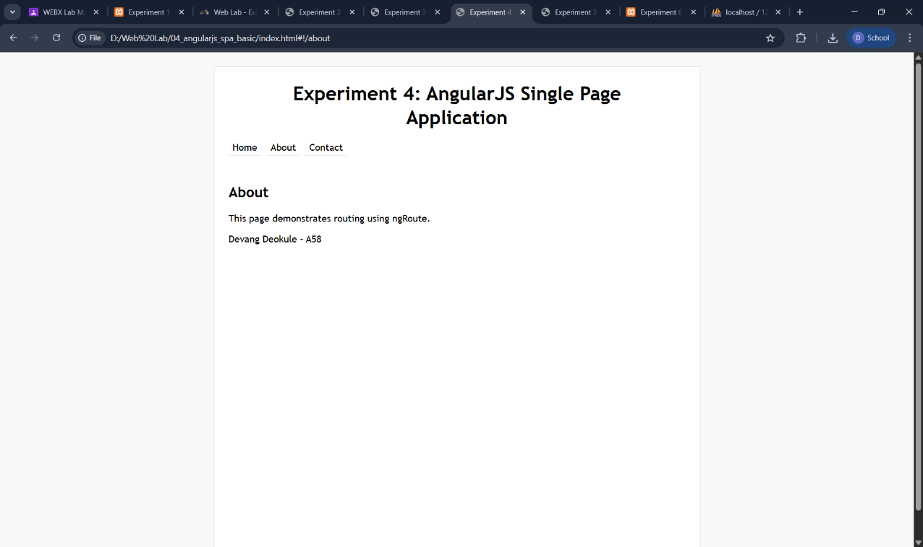

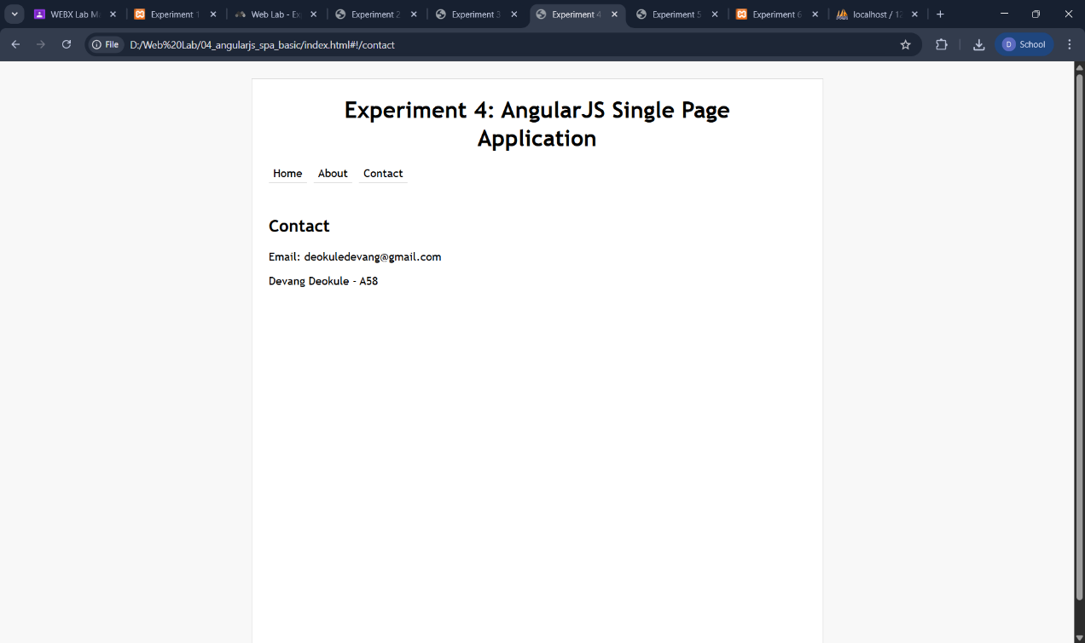

index.html:

<!DOCTYPE html>
<html lang="en" ng-app="advancedSpaApp">
<head>
<meta charset="UTF-8" />
<meta name="viewport" content="width=device-width, initial-scale=1.0" />
<title>Experiment 5 - AngularJS Services Events Validation Helpers</title>
<link rel="stylesheet" href="styles.css" />
<script src="https://ajax.googleapis.com/ajax/libs/angularjs/1.8.3/angular.min.js"></script>
</head>
<body ng-controller="MainController as vm">
<main class="container">
<h1>Experiment 5: AngularJS SPA with Services, Events, Validation, Helpers</h1>

<form name="taskForm" novalidate ng-submit="vm.addTask(taskForm)">
<label for="taskInput">Task</label>
<input
id="taskInput"
name="taskInput"
type="text"
ng-model="vm.newTask"
ng-minlength="3"
required
/>
<small ng-show="taskForm.taskInput.$touched && taskForm.taskInput.$invalid">
Task is required and must be at least 3 characters.
</small>
<button type="submit">Add Task</button>
</form>

<p><strong>Total Tasks:</strong> {{ vm.taskCount() }}</p>

<ul>
<li ng-repeat="item in vm.tasks track by $index">
{{ item.text }}
<button type="button" ng-click="vm.removeTask($index)">Remove</button>
</li>
</ul>

<p aria-live="polite">{{ vm.message }}</p>
<p>Devang Deokule - A58</p>
</main>

<script src="app.js"></script>
</body>
</html>

app.js:

var app = angular.module("advancedSpaApp", []);
app.service("TaskService", function ($rootScope) {
var tasks = [];
this.list = function () {
return tasks;
};
this.add = function (text) {
tasks.push({ text: text.trim() });
$rootScope.$broadcast("task:updated", tasks.length);
};
this.remove = function (index) {
tasks.splice(index, 1);
$rootScope.$broadcast("task:updated", tasks.length);
};
});
app.controller("MainController", function ($scope, TaskService, $filter) {
var vm = this;
vm.tasks = TaskService.list();
vm.newTask = "";
vm.message = "Add a task to begin.";

vm.addTask = function (form) {
if (form.$invalid) {
vm.message = "Please fix validation errors.";
return;
}
var cleanedTask = $filter("uppercase")(vm.newTask.trim());
TaskService.add(cleanedTask);
vm.newTask = "";
form.$setPristine();
form.$setUntouched();
};
vm.removeTask = function (index) {
TaskService.remove(index);
};
vm.taskCount = function () {
return vm.tasks.length;
};
$scope.$on("task:updated", function (_event, count) {
vm.message = "Task list updated. Total tasks: " + count;
});
})

styles.css:

body {
margin: 0;
font-family: Verdana, Geneva, Tahoma, sans-serif;
min-height: 100vh;
display: flex;
justify-content: center;
padding: 1.5rem 1rem;
background: #f8f8f8;
}
.container {
width: min(100%, 760px);
padding: 1.5rem;
border: 1px solid #d8d8d8;
background: #fff;
}
h1 {
max-width: 34ch;
margin: 0 auto 1rem;
text-align: center;
font-weight: 700;
line-height: 1.25;
display: -webkit-box;
-webkit-line-clamp: 2;
-webkit-box-orient: vertical;
overflow: hidden;
}
form {
margin-bottom: 1rem;
display: grid;
gap: 0.6rem;
max-width: 460px;
}
input,
button {
font: inherit;
padding: 0.4rem 0.5rem;
border: 1px solid #555;
}
input {
width: 100%;
box-sizing: border-box;
}
button {
margin-left: 0;
background: #f3f3f3;
width: fit-content;
}
small {
display: block;
margin: 0;
}
ul {
margin-top: 0.9rem;
padding-left: 1.2rem;
}
li {
margin: 0.45rem 0;
}
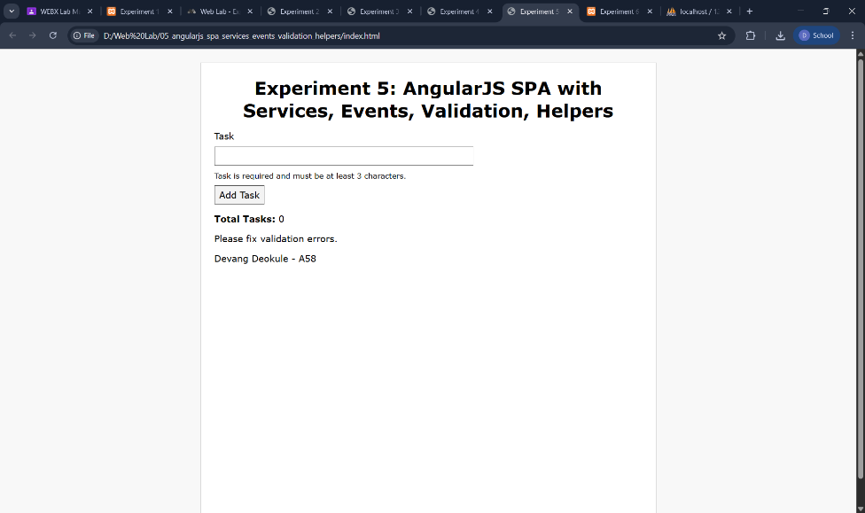
Output:

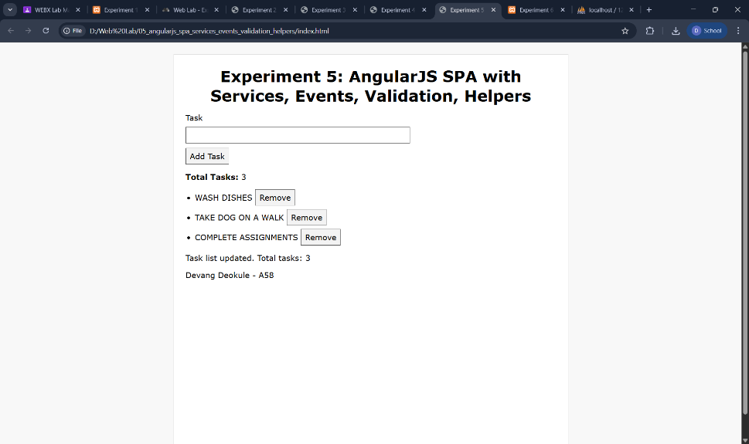

index.html:
<!DOCTYPE html>
<html lang="en">
<head>
<meta charset="UTF-8" />
<meta name="viewport" content="width=device-width, initial-scale=1.0" />
<title>Experiment 6 - AJAX Search</title>
<link rel="stylesheet" href="styles.css" />
</head>
<body>
<main class="container">
<h1>Experiment 6: AJAX Based Search</h1>
<label for="searchInput">Search Users</label>
<input id="searchInput" type="search" placeholder="Type a name..." />
<ul id="results"></ul>
<p>Devang Deokule - A58</p>
</main>
<script src="app.js"></script>
</body>
</html>

app.js:
var input = document.getElementById("searchInput");
var results = document.getElementById("results");
function parseXmlResponse(request) {
var xml = request.responseXML;
if (xml && !xml.getElementsByTagName("parsererror").length) {
return { xml: xml };
}
var raw = request.responseText ? request.responseText.trim() : "";
if (!raw) {
return { error: "Empty response from PHP backend." };
}
if (raw.indexOf("<?php") !== -1) {
return {
error:
"PHP code was returned instead of XML. Run this experiment on a PHP server.",
};
}
var parsed = new DOMParser().parseFromString(raw, "application/xml");
if (parsed.getElementsByTagName("parsererror").length) {
return { error: "Backend response is not valid XML." };
}
return { xml: parsed };
}
function searchUsers(query) {
var request = new XMLHttpRequest();
request.open("GET", "search.php?q=" + encodeURIComponent(query), true);
request.onreadystatechange = function () {
if (request.readyState !== 4) {
return;
}
if (request.status !== 200) {
results.innerHTML = "<li>Unable to fetch data from PHP backend.</li>";
return;
}
var parsed = parseXmlResponse(request);
if (!parsed.xml) {
results.innerHTML = "<li>" + parsed.error + "</li>";
return;
}

var xml = parsed.xml;
var errorNode = xml.getElementsByTagName("error")[0];
if (errorNode) {
results.innerHTML = "<li>" + errorNode.textContent + "</li>";
return;
}
var users = xml.getElementsByTagName("user");
render(users);
};
request.send();
}
input.addEventListener("input", function () {
searchUsers(input.value.trim());
});
function render(userNodes) {
if (!userNodes.length) {
results.innerHTML = "<li>No matching users.</li>";
return;
}
var html = "";
for (var i = 0; i < userNodes.length; i++) {
var name = userNodes[i].getElementsByTagName("name")[0].textContent;
var email = userNodes[i].getElementsByTagName("email")[0].textContent;
html += "<li>" + name + " (" + email + ")</li>";
}
results.innerHTML = html;
}
searchUsers("");

search.php:

<?php
declare(strict_types=1);
header('Content-Type: application/xml; charset=UTF-8');
$query = isset($_GET['q']) ? trim((string) $_GET['q']) : '';
$xmlPath = __DIR__ . '/users.xml';
function xmlEscape(string $value): string
{
return htmlspecialchars($value, ENT_XML1 | ENT_QUOTES, 'UTF-8');
}
if (!file_exists($xmlPath)) {
http_response_code(500);
echo "<?xml version=\"1.0\" encoding=\"UTF-8\"?>\n";
echo "<results><error>Backend XML file not found.</error></results>";
exit;
}
if (!function_exists('simplexml_load_file')) {
http_response_code(500);
echo "<?xml version=\"1.0\" encoding=\"UTF-8\"?>\n";
echo "<results><error>SimpleXML extension is not enabled in PHP.</error></results>";
exit;
}
libxml_use_internal_errors(true);
$users = simplexml_load_file($xmlPath);
if ($users === false) {
libxml_clear_errors();
http_response_code(500);
echo "<?xml version=\"1.0\" encoding=\"UTF-8\"?>\n";
echo "<results><error>Unable to read backend XML file.</error></results>";
exit;
}
libxml_clear_errors();
$response = "<?xml version=\"1.0\" encoding=\"UTF-8\"?>\n<results>";
foreach ($users->user as $user) {
$name = trim((string) $user->name);
$email = trim((string) $user->email);
if ($query !== '' && stripos($name, $query) === false) {
continue;
}
$response .= '<user>';
$response .= '<name>' . xmlEscape($name) . '</name>';
$response .= '<email>' . xmlEscape($email) . '</email>';
$response .= '</user>';
}
$response .= '</results>';
echo $response;

users.xml:
<?xml version="1.0" encoding="UTF-8"?>
<users>
<user>
<name>Devang Deokule</name>
<email>devang.deokule@gmail.com</email>
</user>
<user>
<name>Viraj Jadhav</name>
<email>viraj.jadhav@gmail.com</email>
</user>
<user>
<name>Atharv Jadhav</name>
<email>atharv.jadhav@gmail.com</email>
</user>
<user>
<name>Chinmay Nagap</name>
<email>chinmay.nagap@gmail.com</email>
</user>
<user>
<name>Rohan Pednekar</name>
<email>rohan.pednekar@gmail.com</email>
</user>
<user>
<name>Sahil Bandhare</name>
<email>sahil.bandhare@gmail.com</email>
</user>
<user>
<name>Aayush Repote</name>
<email>aayush.repote@gmail.com</email>
</user>
<user>
<name>Sohail Shaikh</name>
<email>sohail.shaikh@gmail.com</email>
</user>
</users>
styles.css:
body {
margin: 0;
font-family: "Segoe UI", sans-serif;
min-height: 100vh;
display: flex;
justify-content: center;
padding: 1.5rem 1rem;
background: #f8f8f8;
}
.container {
width: min(100%, 700px);
padding: 1.5rem;
border: 1px solid #d8d8d8;
background: #fff;
}
h1 {
max-width: 30ch;
margin: 0 auto 1rem;
text-align: center;
font-weight: 700;
line-height: 1.25;
display: -webkit-box;
-webkit-line-clamp: 2;
-webkit-box-orient: vertical;
overflow: hidden;
}
input {
width: 100%;
max-width: 360px;
padding: 0.48rem;
border: 1px solid #555;
}
ul {
margin-top: 1rem;
padding-left: 1.2rem;
}
li {
margin: 0.4rem 0;
}

Output:

